Thread False Sharing

False sharing is a performance problem in multithreaded programs that occurs when multiple threads update different variables that happen to reside on the same CPU cache line.
Even though the threads are not logically sharing data, the CPU’s cache coherence protocol treats the entire cache line (typically 64 bytes) as shared. As a result, each write by one thread invalidates the cache line in other cores, causing excessive cache traffic and slowing everything down.
False sharing is about memory layout, not atomicity or size.
Smaller fields (like boolean) are often worse than larger ones.

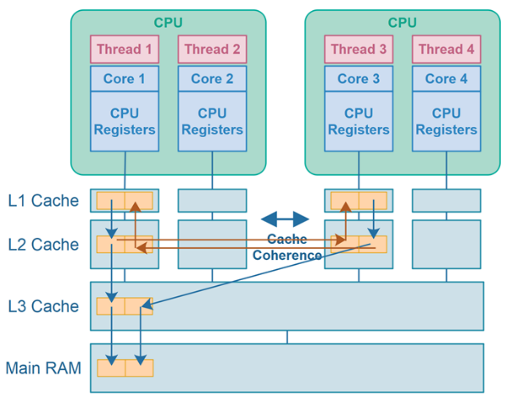 | 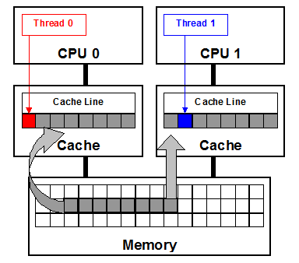

Simple example:
class Counters {
volatile long a; // Thread 1 updates
volatile long b; // Thread 2 updates
}
If a and b land in the same cache line, both threads constantly invalidate each other’s caches — even though they never touch the same variable.

Cache lines and speed
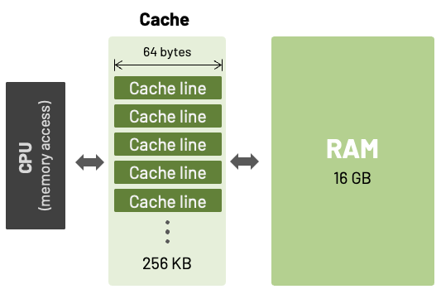 | 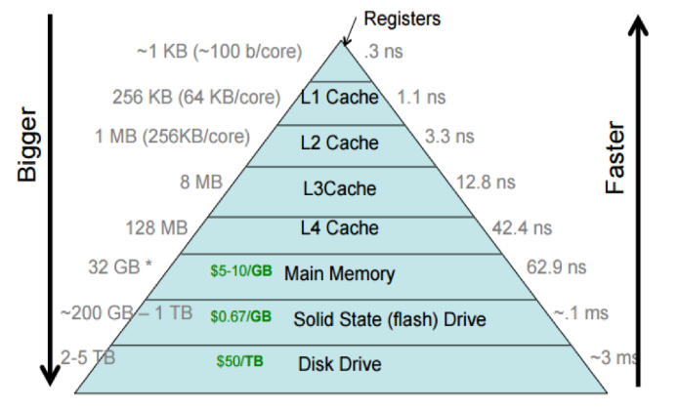

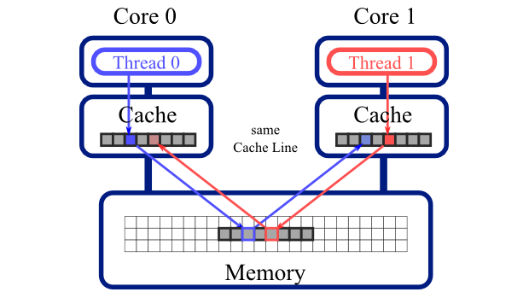

Easy explanation 👇
Imagine two people sharing a table 🪑🪑
- Person A is working on the left side
- Person B is working on the right side
They are not touching each other’s work,
but every time one person moves, the whole table shakes, disturbing the other.
👉 That shaking is false sharing.

In computers (simple terms)
- Modern CPUs work with cache lines (small blocks of memory, e.g. 64 bytes)
- If two threads modify different variables
- But those variables are stored inside the same cache line
- The CPU keeps invalidating and reloading the cache line
⚠️ Even though the threads are not sharing the variable,
they are sharing the cache line → false sharing
Very small example:
- Core 1 changes value X
- Core 2 has X in its cache

- Each CPU core keeps cached copies of memory
- If one core changes data
- Other cores’ cached copies become stale
- The CPU invalidates those cached copies
- Core 1 change value (x + 1) and Core 2 copies the unchanged data (x), its stale data
- Core 2 invalidate and re-copie the data again, now has (x + 1)

Correct sequence (simple & accurate)
- Initial state
- Core 1 cache: X = x
- Core 2 cache: X = x
- Core 1 updates X
- Core 1 changes X → x + 1
- Cache coherence kicks in
- Core 2’s cached copy of X is invalidated
(marked "invalid", not usable)
- Core 2 wants to read X
- It sees its cache line is invalid
- It cannot read the old value x
- Core 2 reloads the data
- Core 2 fetches X again → gets x + 1

How the JVM Handles (or Avoids) False Sharing
The JVM does not automatically prevent false sharing, but it provides tools and techniques to deal with it.
- Field Padding (Manual or JVM-assisted)
class PaddedCounter {
volatile long value;
// padding
long p1, p2, p3, p4, p5, p6, p7;
}
✔ Works
✘ Ugly, non-portable, error-prone
- @Contended Annotation (Modern JVM Solution)
@sun.misc.Contended
class Counter {
volatile long value;
}

or on fields:
class Counters {
@sun.misc.Contended
volatile long a;

@sun.misc.Contended
volatile long b;
}

What it does:
- Forces the JVM to place the annotated field/object on its own cache line
- Inserts padding before and after
Requirements:
-XX:-RestrictContended
Notes:
- Available since Java 8 (standardized via JEP 142)
- Disabled by default to avoid memory bloat
- Used heavily in high-performance libraries (e.g., Disruptor)
Aspect | Explanation
False sharing | Cache-line level contention without logical sharing
Root cause | CPU cache coherence protocols
Default JVM behavior | No automatic protection
Main JVM tool | @Contended + -XX:-RestrictContended
Best solution | Data layout & thread ownership

Core JDK libraries that handle false sharing internally
Libraries:
- java.util.concurrent.atomic
- LongAdder
- DoubleAdder
- java.util.concurrent.atomic
- ConcurrentHashMap
- ForkJoinPool
- ThreadLocalRandom
- Exchanger
JDK Component | False Sharing Strategy
LongAdder / DoubleAdder | Striping + padding
ConcurrentHashMap | Striped counters + padded control
ForkJoinPool | Padded worker & queue fields
ThreadLocalRandom | Thread confinement
Exchanger | Padded slots
JVM internals | Manual padding everywhere

NOTE:
False sharing is about memory layout, not atomicity or size.
Smaller fields (like boolean) are often worse than larger ones.

Boolean
Variable Type | False Sharing Risk
boolean | 🔥 Very high
boolean[] | 🔥🔥 Extremely high
AtomicBoolean | 🔥 High
Padded boolean | ✅ Safe
@Contended boolean | ✅ Best

Is false sharing an issue with String?
❌ Directly: NO
- String objects are immutable
- You don’t update String contents
- False sharing requires frequent writes
- Reads alone do not cause cache-line ping-pong
➡️ So updating a String itself cannot cause false sharing

❌ Common misconception
“Strings are immutable, so false sharing is impossible”
❌ Wrong
Correct statement:
String contents are immutable, but String references are mutable.
False sharing cares about memory writes, not object mutability.

ConcurrentHashMap Comparison table
Map type | Thread-safe | Avoids false sharing | Scales
CHM<Integer, Integer> | ✅ | ❌ | ❌
CHM<Integer, AtomicInteger> | ✅ | ❌ | ⚠️
CHM<Integer, LongAdder> | ✅ | ✅ | ✅

Problem with ConcurrentHashMap<Integer, Integer>
- All threads hit the same key
- All threads mutate the same bin
- New Integer every time
- Cache-line ping-pong on bin & node fields

False-Sharing handle by ConcurrentHashMap<Integer, LongAdder>
- No object replacement
- No per-update allocation
- LongAdder internally avoids false sharing
- Contention is spread across cache lines

Summary table
Layer | Technique | False sharing handled
ConcurrentHashMap internals | Striped counters + padded control | ✅
User values (Integer) | None | ❌
User values (LongAdder) | Striped + padded | ✅
Overall map + values | Depends on value type | ⚠️

Comparison matrix (HM vs CHM)
Map | Value | Thread-safe | Avoids false sharing
HashMap<Integer, Integer> | Integer | ❌ | ❌
HashMap<Integer, AtomicLong> | AtomicLong | ❌ | ❌
HashMap<Integer, LongAdder> | LongAdder | ❌ | ✅ (value only)
ConcurrentHashMap<Integer, LongAdder> | LongAdder | ✅ | ✅
ConcurrentHashMap<Integer, Integer> | Integer | ✅ | ❌

NOTE:
@Contended adds padding before and after a field, but only works if you enable it with
-XX:-RestrictContended.

When you SHOULD use @Contended
✅ High-contention primitives
✅ Counters
✅ Ring buffers
✅ Lock-free algorithms
✅ JVM-level concurrency structures

Lock-Free Libraries
Production-grade lock-free (or mostly lock-free) libraries and implementations available for Java today, grouped by category. These are existing libraries, not academic examples.
Lock-free library:
Library | Primary Use | Lock-Free
JDK Concurrent* | General concurrency | ✅
JCTools | High-perf queues | ✅
LMAX Disruptor | Event processing | ✅
Agrona | Low-level primitives | ✅
Aeron | Messaging | ✅
Akka | Actor systems | Internally
Netty | Networking | Internally
Chronicle Queue | Persistent queues | Mostly

- Core JDK (Already Lock-Free Internally)
Always prefer these first — they are battle-tested and heavily optimized.
java.util.concurrent
- ConcurrentLinkedQueue
- ConcurrentLinkedDeque
- LongAdder, DoubleAdder
- Atomic* classes
- ForkJoinPool (work-stealing queues)
✔ Mostly lock-free
✔ Maintained by the JDK
✔ Best default choice

- High-Performance Lock-Free Libraries
🔹 JCTools
The most important external lock-free library for Java
- Lock-free queues (SPSC, MPSC, MPMC)
- Used by Netty, Aeron, Akka
- Extremely low-latency
- CAS + memory-ordering optimized
Examples:
- SpscArrayQueue
- MpscLinkedQueue
- MpmcArrayQueue
📌 Best choice for custom high-performance queues

🔹 Agrona
Low-level primitives for lock-free systems.
- Lock-free ring buffers
- Atomic counters
- Memory-mapped buffers
- Used by Aeron
📌 Ideal for low-latency messaging systems

🔹 Aeron
A full messaging system built on lock-free principles.
- Lock-free IPC & UDP messaging
- Backpressure-aware
- Used in trading systems
📌 Use when building ultra-low-latency distributed systems

- Actor / Reactive Systems (Internally Lock-Free)
🔹 Akka
- Lock-free mailboxes
- CAS-based scheduling
- Message-passing instead of locks
📌 You don’t write lock-free code — Akka does it for you

🔹 LMAX Disruptor
Famous lock-free ring buffer.
- Mechanical-sympathy focused
- Extremely low GC & latency
- Used in finance & trading
📌 Best for event pipelines & streaming

- Specialized Libraries
🔹 Chronicle Queue
- Lock-free off-heap queues
- Persistent & memory-mapped
- Designed for low latency + durability

🔹 Netty
- Internally uses lock-free queues
- Event-loop architecture
- High-performance networking
java.util.concurrent
- ConcurrentLinkedQueue
- ConcurrentLinkedDeque
- LongAdder, DoubleAdder
- Atomic* classes
- ForkJoinPool (work-stealing queues)

